CHAPTER 7

GENERAL DESCRIPTION

Layout of Concurrent Train Simulation Sytem

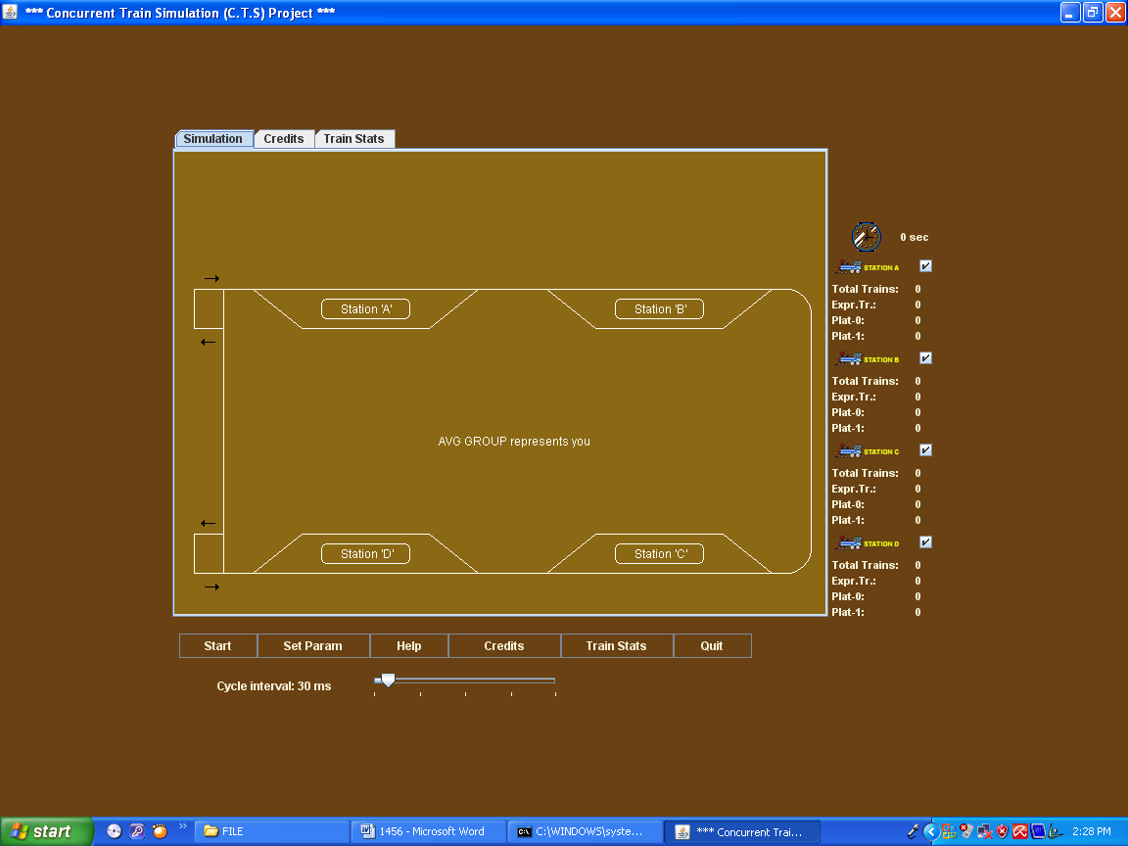

Active CTS System
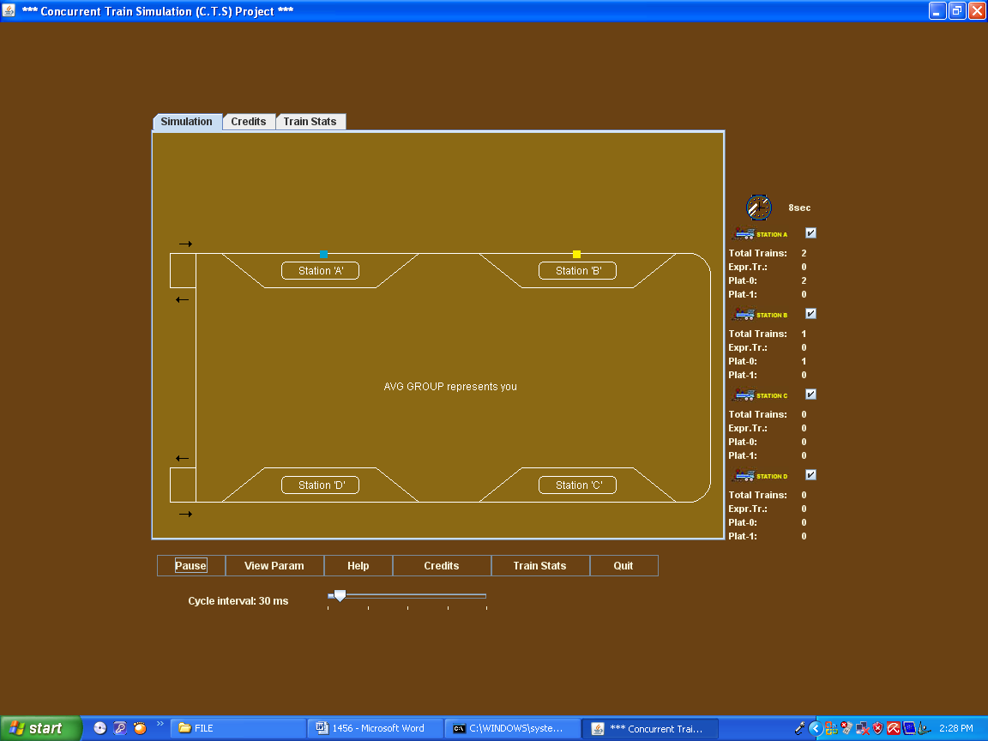

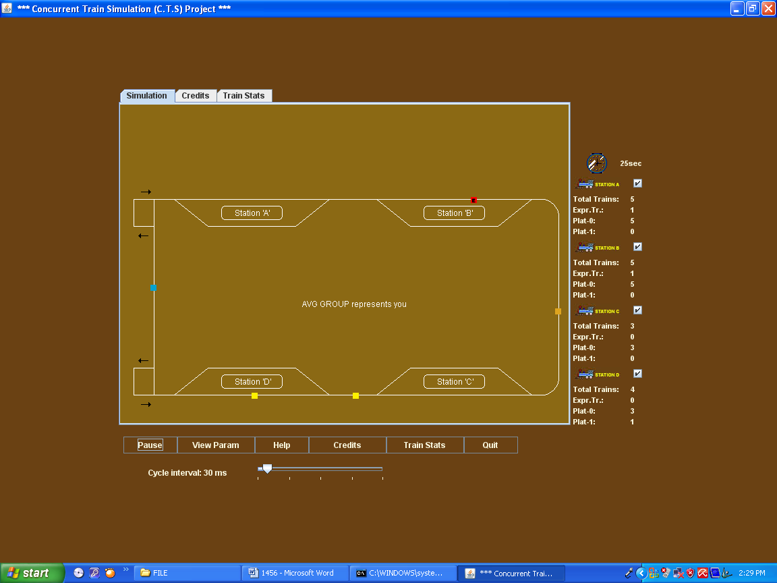

Description

In this layout when we press the “start” button train insert on railway track.
These trains come according to the set parameter. In parameters train insertion time, time delay between trains no. Of train, the user of CTS system sets simulation speed.

When start button is pressed it converts in pause button which is use for paused the concurrent train simulation system.

On the fig we see four stations “Station A”, “Station B”, “Station c”, “Station D”. These stations are the stoppage of trains which are selected.
We use CheckButton on the stations these check button are use for select the stoppage of trains . These station shows four parameter .
How much no. of trains passes from the stations.
How much no. of express train passes from railway station.
How much no. of train passes from plot 0.
How much no. of train passes from plot 1.

.

CTS Parameter setup Panel

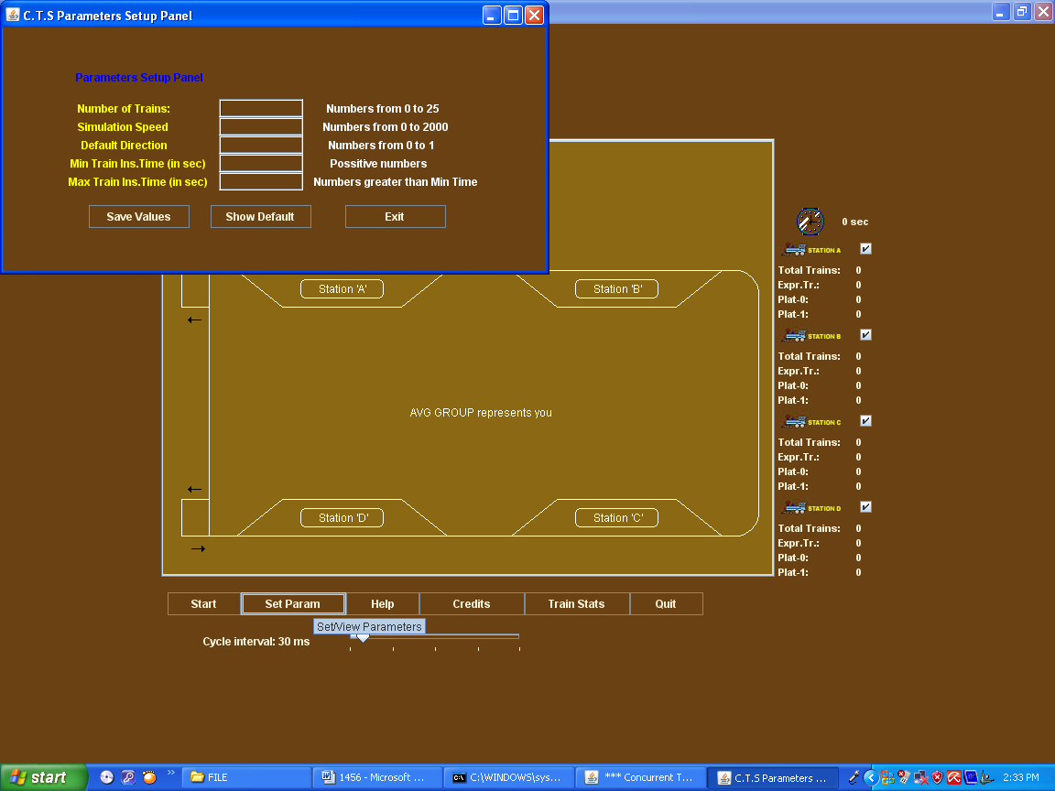

Description

In parameter setup panel parameters are set for train and for railway track.
These parameters are set before start the simulation.

Parameters are:
1. Number of train
These parameter shows no. of parameter on railway track. This decided by user. In our project by default we set 25 trains on the track.

2. Simulation Speed
This parameter use for adjust the simulation speed of the CTS System. How much fast trains run on railway track.

3. Default Direction
In this parameter we use only two direction 0 or 1.
0 is use for forward direction and 1 is use for reverse direction.

4. Min train Insertion time
This time shows min time of train to reach on railway track.

5. Max train insertion time
This time shows min time of train to reach on railway track. In our project we use this time in seconds.
All these parameters are set before run the software and set by the user of this software.
Three buttons are use in this panel
1. Save Values
This Button is use for save the new parameter which are set by user of CTS system.
2. Show Default
This button use to show the default parameter which sre set by the programmer.
3. Exit

This button is use for going out from the set parameter window.

This Window is use for seen the parameter which are set by the user. This window is shown after run the software and we see the parameter by using view parameter button. This button comes after run the software because set parameters convert in the view parameter. It shows all the value which are set by the user.

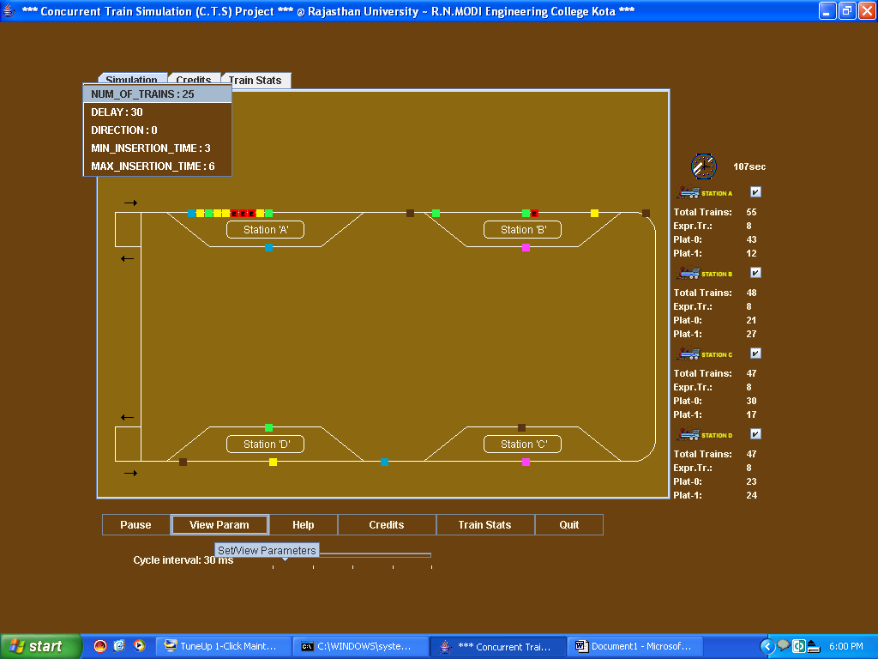
Help Window

This window is use for the help for new user who are unknown about this software. It gives information about the software and how to run this software. This window comes after pressing the help button of the
software.

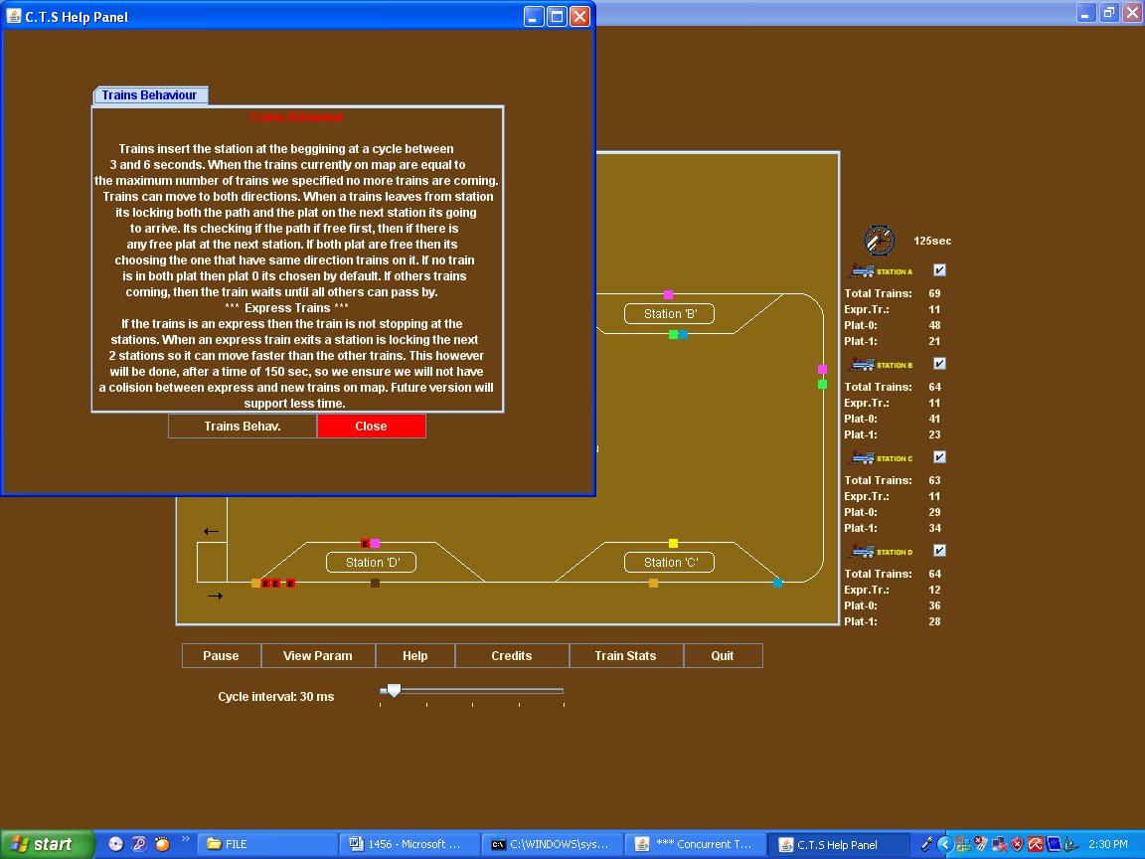

Train status window

Train status window shows the status of all active train which are run on the railway track.
How it works
Fist of all select the train whose status you want to check. Then select active states
And select yes.
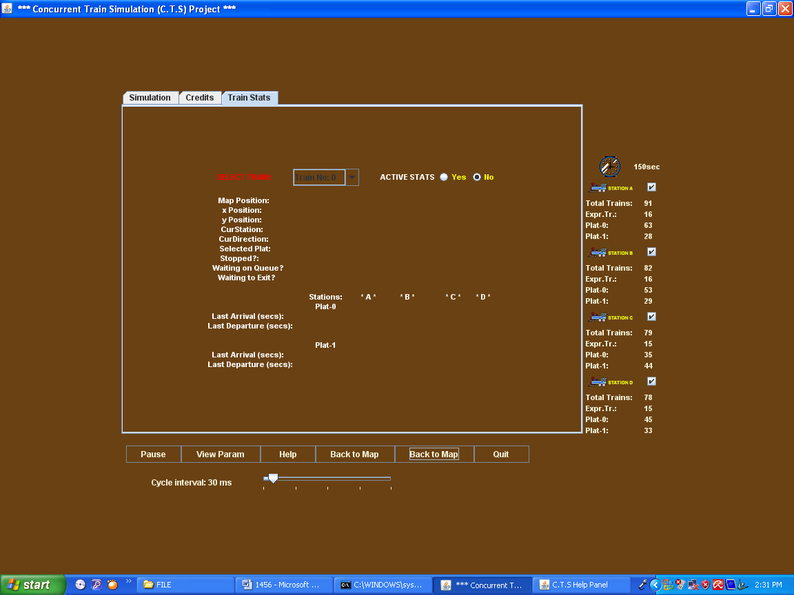

After that all updated result shown to you.

Results are
Position on map
It shows position of train on the map that is design by the developer.
Xposition
It shows position of train according to the X-axis.
Yposition
It shows position of train according to the Y-axis.
Current railway station
In this status it shows current railway station. Which are present on map. And if train is out of station than it shows train is out of station.
Current Direction
It shows current direction of train. Train is move left side or right side.
Selected plot
It shows the plot, which is selected by user Plot 0 or Plot 1
Stopped
Where the train is stopped on which position of railway track.
Waiting on queue
It shows the position of the train on waiting queue.
This panel also contains the information of train arrival & departure time.
On plot 0 or on plot 1 of railway station.
Back to map button
Back to map button use for go to the map

CREDIT WINDOW

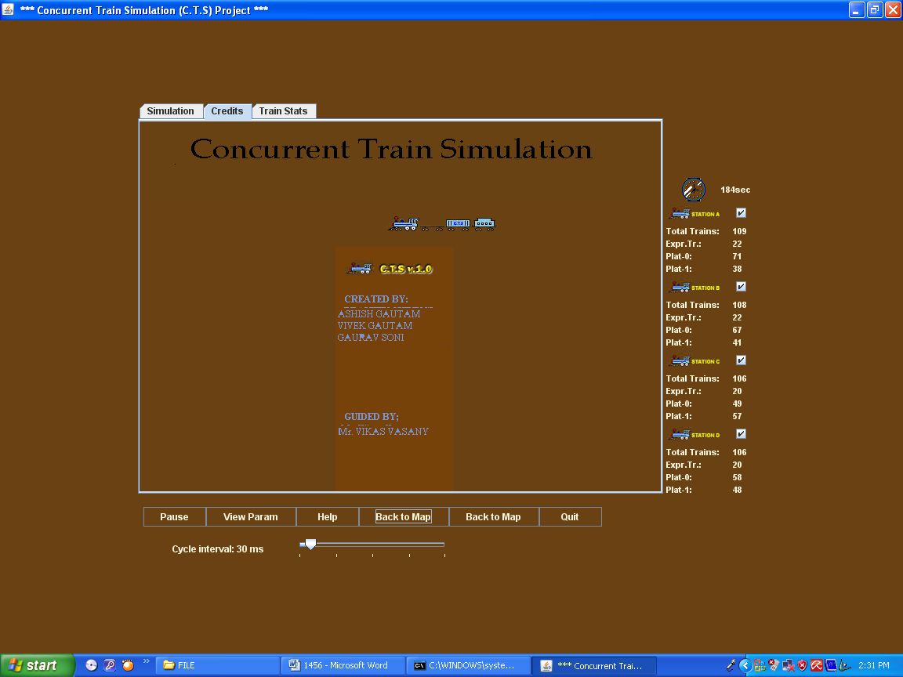

DESCRIPTION
It shows information about the developers of this projects

